Hands On Exercises - Java 8 Advanced Concurrent Patterns

**Setup Instructions:**

1. Create a new Java Project called “FullStackDay10”.
2. Create your classes in the specified package.
3. Define your classes as given below for each assignment.

Assignment 01

The following exercise demonstrates how ConcurrentHashMap is used in a multi-threaded context. The program creates two writer threads and 5 reader threads working on a shared instance of a ConcurrentHashMap.

The writer thread randomly modifies the map (put and remove). Here’s the code:

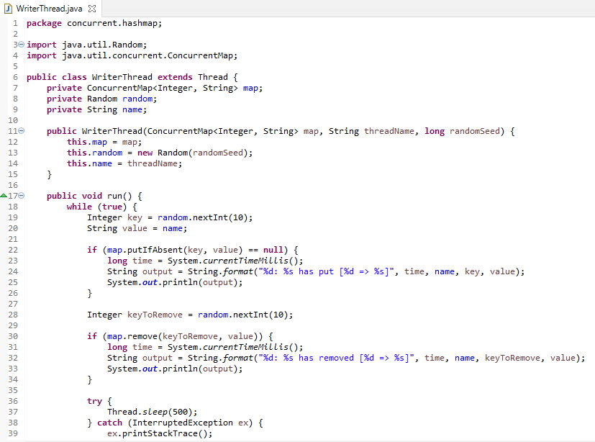

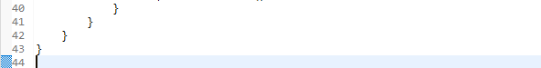

The reader thread iterates over each key-value pair in the map and prints it out. Here’s the code:

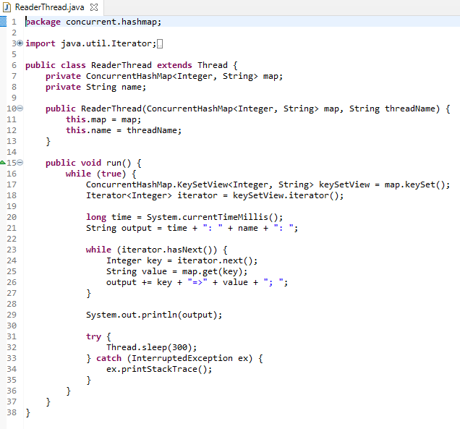

And the main program creates and starts 2 writer threads and 5 reader threads to work concurrently on a shared instance of a ConcurrentHashMap. Here’s the code:

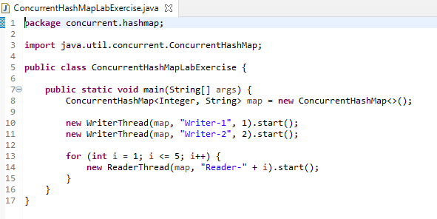

This program runs forever because all threads run an infinite loop, so you need to press thr square red button on the console in Spring Tool Suite to stop the program and observe the output. The reader threads let you know that the mp is constantly updated by the writer threads. Here’s a screenshot captured when running the above program in Spring Tool Suite:

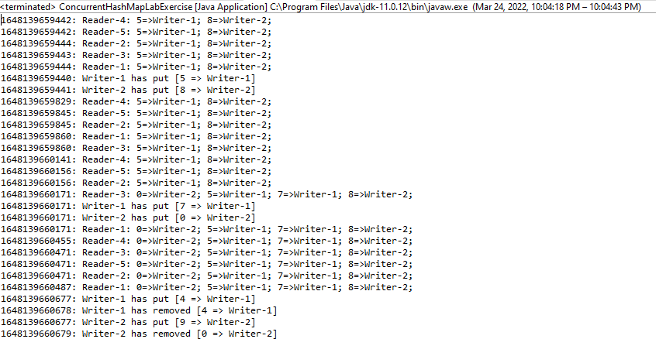

Assignment 02

In this exercise,you will learn how to work with ConcurrentHashMap in Java, like creating a map, inserting key-value pairs, updating a key-value pair, deleting a mapping, check if a key or value exists in the map, iterating over keys or values, and so on.





